09-Manage Azure Virtual Machines

Lab Objective
In this lab, you learn how to:
- Create Azure Virtual Machines (VMs)
- Achieve high availability using Availability Zones
- Scale VMs manually (vertical scaling)
- Automate scaling using Virtual Machine Scale Sets (VMSS)
- Configure autoscaling rules
- Create VMs using Azure Portal, PowerShell, and CLI

Business Scenario (Why This Lab Matters)
Your organization wants to:
- Run applications on Azure VMs
- Ensure high availability
- Increase or decrease compute based on demand
- Reduce manual effort using autoscaling
Azure Virtual Machines Architecture Diagram
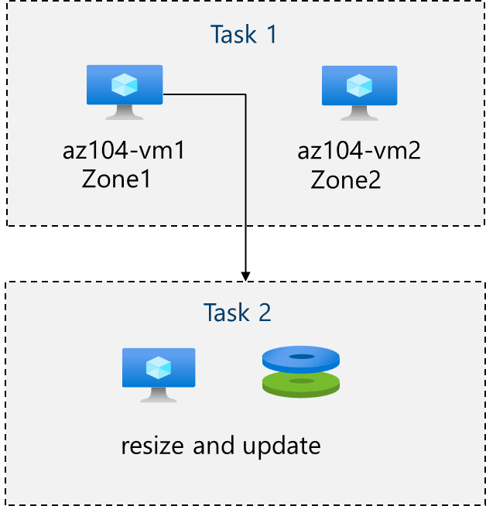

Core Concepts (Must Understand First)

What is an Azure Virtual Machine?
An Azure Virtual Machine is:
- An on-demand compute resource
- Similar to a physical or VMware server
- Runs Windows or Linux
- Fully managed by Azure infrastructure
You control:
- OS
- VM size (CPU & RAM)
- Storage
- Networking

What Are Availability Zones?
Availability Zones (AZs) are:
- Physically separate datacenters within the same region
- Each zone has independent power, cooling, and networking

Why Use Availability Zones?
Benefit | Explanation
High availability | Protects against datacenter failure
99.99% SLA | Requires at least 2 VMs in different zones
✔ In this lab:
Two VMs are deployed across Zone 1 and Zone 2

Task 1: Deploy Zone-Resilient Virtual Machines

What You Did
- Created two VMs in different availability zones
- Used the same configuration
- No load balancer (manual access only)

Key Configuration Concepts

VM Size
Component | Description
vCPU | Processing power
RAM | Memory
SKU | Combination of CPU, RAM, disk limits
Example:
- Standard_D2s_v3 = balanced compute and memory

OS Disk Type
Disk Type | Use Case
Standard HDD | Low cost, low performance
Standard SSD | Balanced
Premium SSD | High performance
✔ Used: Premium SSD

Public Inbound Ports
- Disabled to improve security
- No RDP or SSH exposed to the internet

Task 2: Manage Compute and Storage Scaling

Vertical Scaling (Resize VM)

What is Vertical Scaling?
Vertical scaling means:
- Changing VM size
- Increasing or decreasing CPU and RAM
✔ Example:
- From D2s_v3 → D2ds_v4
⚠ VM may briefly restart during resize.

Disk Scaling Concepts

Data Disks
- Used to store application data
- Can be:
  - Attached
  - Detached
  - Resized
  - Reused

Disk Detach vs Delete
Action | Result
Detach | Disk remains in Azure
Delete | Disk is permanently removed

Change Disk Performance
You can:
- Change disk type without data loss
Example:
- Standard HDD → Standard SSD

Why Manual Scaling Is Limited
- Requires human intervention
- Not suitable for:
  - Traffic spikes
  - Large workloads
  - High availability systems
➡ This leads to Virtual Machine Scale Sets

Task 3: Create Azure Virtual Machine Scale Sets (VMSS)

What is a VM Scale Set?
A Virtual Machine Scale Set:
- Is a group of identical VMs
- Created from the same image and configuration
- Automatically scales in or out

VMSS vs Single VM
Feature | Single VM | VM Scale Set
Scaling | Manual | Automatic
High availability | Limited | Built-in
Load balancing | Optional | Integrated
Admin effort | High | Low

Uniform Orchestration Mode
- All VMs are identical
- Best for stateless workloads
- Simplifies management

Networking in VMSS

Network Security Group (NSG)
Controls:
- Inbound and outbound traffic
✔ Allowed:
- HTTP (Port 80)

Load Balancer Integration
VMSS:
- Automatically integrates with Azure Load Balancer
- Distributes traffic evenly across VM instances

Task 4: Scale VM Scale Sets (Autoscaling)

What is Autoscaling?
Autoscaling automatically:
- Adds VMs when demand increases
- Removes VMs when demand decreases
Based on:
- Metrics
- Rules
- Schedules

Scale-Out Rule (Increase Capacity)
Condition:
- Average CPU > 70%
- Duration: 10 minutes
Action:
- Increase VM count by 50%
Purpose:
- Handle high load

Scale-In Rule (Reduce Capacity)
Condition:
- Average CPU < 30%
- Duration: 10 minutes
Action:
- Decrease VM count by 50%
Purpose:
- Save cost during low usage

Instance Limits (Safety Controls)
Setting | Meaning
Minimum | Never go below this
Maximum | Never exceed this
Default | Starting instance count
✔ Used:
- Min: 2
- Max: 10
- Default: 2

Task 5 & 6: VM Creation Using PowerShell and CLI

Why Use PowerShell / CLI?
- Automation
- Scripting
- Infrastructure as Code (IaC)
- Faster deployments

VM Power States
State | Cost Impact
Running | Compute + storage
Stopped | Still charged
Deallocated | Storage only
✔ Always deallocate unused VMs to save cost.

